Уварова В.Е. 12-МАР-2
Стилеобразование в новейшей архитектуре
Название стиля
Представитель | Описание работ | Графическое изображение к описанию
Архитектура 1970-1990-х годов. Поздний модернизм. 19701990-е годы. Рационалистские направления.
Монументальный экспрессионизм 1970-1990-х годов.
Johan Otto von Spreckelsen (May 4, 1929—March 16, 1987) was a Danish architect. | He directed the creation of several modern churches in Denmark, VangedeKirke near Copenhagen (1974), StavnsholtKirke at the city of Farum (1981) and the two Roman Catholic churches in Esbjerg and Hvidovre both consecrated to Saint Nicholas. His best known work however is the Grande Arche at La Défense in Paris.  He was a modest man, who once in an interview declared that he was an architect who built three churches and one Arch. He relied heavily on simple geometrical figures, especially the quadrant, which can be seen in his churches, in the interior decorations even of church organs. | Spreckelsen' childhood home in Viborg  VangedeKirke  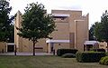StavnsholtKirke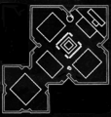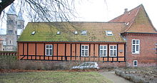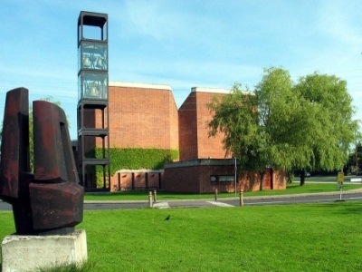
Emilio Ambasz (born 13 June 1943, Resistencia, Chaco) | Ambasz's trademark style is a combination of buildings and gardens, which he describes as 'green over grey'. He bucked the trends of the 1970's, hiding his buildings under grass or putting them on boats.  The Emilio Ambasz Award for Green Architecture is awarded every year by the Architecture Israel Quarterly magazine. | 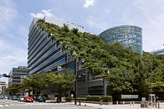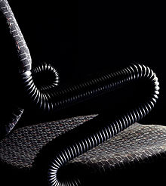
Dominique Perrault  (Clermont-Ferrand, 1953) | Вelongs to the few international stars among French architects.  We are still working on details pertainingto our metallic stitches, in particular for thewrapping of the Grand Theater in Albi. Thiselement protects the facade from the wind andfrom the sun. There are in this case again manydetails to resolve for the hanging of the structure.Also details pertaining to tensions and torsions.What I want is a bi-dimensional effect of torsion.I am also working on some details about stairsand lifelines for the Dobrée Museum in Nantes,and on a thousand other things, for exampledetails for various facades. Anotherproject I am working on a lot is piazza Garibaldi inNaples, where all details count in order to makethis fascinating square a better place to live. Andbelieve me, that is not a detail in the life of city. | 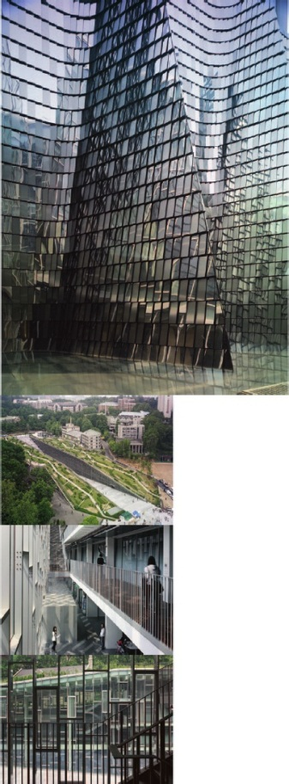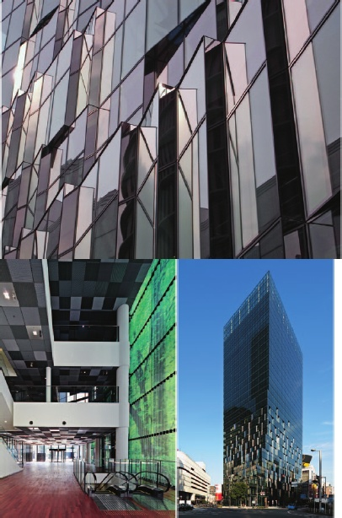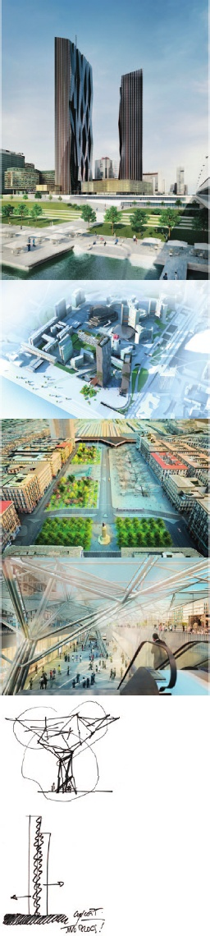
Архитектура 1970-1990-х годов. Поздний модернизм.
19701990-е годы рациональистические направления. High-tech
Senator Renzo Piano, Ufficiale OMRI (Italian: [ˈrɛntso ˈpjano]; born 14 September 1937) | Is an Italian Pritzker Prize-winning architect.  Piano's recent expansion of the Art Institute of Chicago includes a 264,000-square-foot (24,500 m²) wing with 60,000 square feet (5,600 m²) of gallery space called the Modern Wing, which opened on 16 May 2009. It includes a "flying carpet", a sunscreen that hovers above the roof and a 620-foot (190 m) steel bridge connecting Millennium Park to a sculpture terrace that leads into a restaurant on the wing’s third floor.  His current projects include the The Shard, Europe's tallest skyscraper which was opened on July 6, 2012, and the Centro de Arte Botín. The Botin Foundation,^{[11]} the largest private foundation in Spain, will invest over US $150 million for the construction and programming of a new Botín Center that will become an international reference in culture and education for the development of creativity through art. Another controversial project nearing its completion is the Valletta City Gate in Malta which may result in the City's loss of its UNESCO title.  On 30 August 2013 he was appointed senator for life because of his "outstanding cultural achievements" by the President of the Italian Republic. | 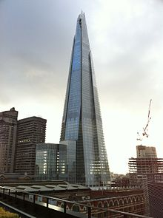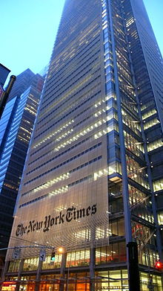  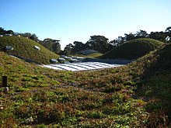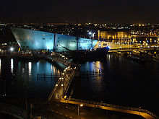
Richard George Rogers, Baron Rogers of Riverside (born 23 July 1933) | Is a British architect noted for  his modernist and functionalist designs.  He continued to develop his ideas of prefabrication and structural simplicity to design a Wimbledon house for his parents. This was based on ideas from his conceptual 'Zip Up' house, such as the use of standardised components based on refrigerator panels to make energy-efficient buildings. Rogers subsequently joined forces with Italian architect Renzo Piano, a partnership that was to prove fruitful. His career leapt forward when he, Piano andGianfrancoFranchini won the design competition for the Pompidou Centre in July 1971, alongside a team from Ove Arup that included Irish engineer Peter Rice.This building established Rogers's trademark of exposing most of the building's services (water, heating and ventilation ducts, and stairs) on the exterior, leaving the internal spaces uncluttered and open for visitors to the centre's art exhibitions. This style, dubbed "Bowellism" by some critics, was not universally popular at the time the centre opened in 1977, but today the Pompidou Centre is a widely admired Parisian landmark. | 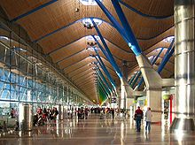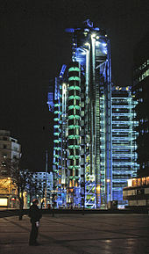  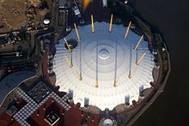
Norman Robert Foster, Lord Foster of Thames Bank, (born 1 June 1935) | Is a British architect whose company maintains an international design practice, Foster + Partners.  After Team 4 went their separate ways, Foster and Wendy Cheesman founded Foster Associates, which later became Foster and Partners in 1967. A long period of collaboration with American architect Richard Buckminster Fuller began in 1968 and continued until Fuller's death in 1983. They collaborated on several projects that became catalysts in the development of an environmentally sensitive approach to design – including the Samuel Beckett Theatre project.  Originally they concentrated on industrial buildings. The turning point was the 1969 administrative and leisure center for Fred. Olsen Lines in London Docklands, where workers and managers are not separated any more.^{[22]} Foster and Partners' breakthrough building in the UK was the Willis Faber & Dumas headquarters in Ipswich, of 1974. The client was a family run insurance company which wanted to restore a sense of community to the workplace. Foster created open plan office floors long before open-plan became the norm. In a town not over-endowed with public facilities, the roof gardens, 25 metre swimming pool and gymnasium enhanced the quality of life for the company's 1200 employees.^{[23]} The building has a full-height glass facade moulded to the medieval street plan and contributes drama, subtly shifting from opaque, reflective black to a glowing backlit transparency as the sun sets. The design was inspired by the Daily Express Building in Manchester a work Foster admired in his youth. Thebuildingisnow Grade II* listed. | 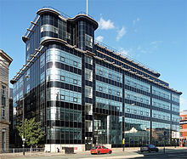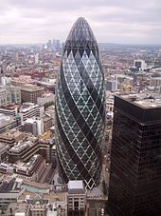  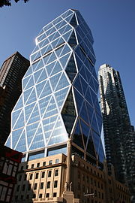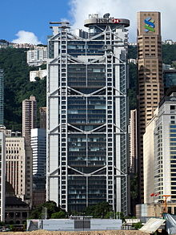
Архитектура 1970-1990-х годов. Поздний модернизм. 19701990-е годы. Рационалистские направления.
Иррационалuстские направления. Органический скульптуролизм инеоэкспрессuонuзм 19702000-х годов
(Bart Prins) родился в США, живет в Альбукерке, штат Нью-Мексико. | Он известен как последователь органической архитектуры Фрэнка Ллойда Райта. Основной принцип его подхода к проектированию – это природная пластика форм и гармония с окружающей средой. Его дома словно вырастают из ландшафта и его материалов. Принс говорит, что его проекты начинаются изнутри-наружу, и что каждый его дом, имеет под собой свой особый уникальный замысел. | 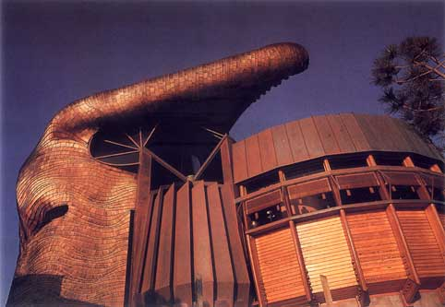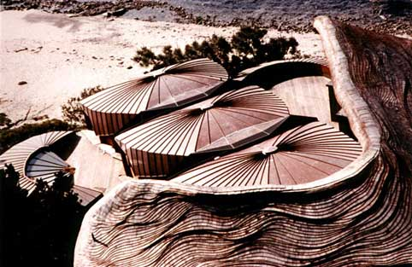
Ricardo Porro is a Cuban-born architect (b. 1925). | Porro fled to Venezuela in early 1958, where he taught architecture and worked in the BancoObrero project led by famed architect Carlos Raúl Villanueva. While in Venezuela, Porro met two Italian expatriate architects: Roberto Gottardi and Vittorio Garatti. Following the victory of the Cuban Revolution, Porro returned to Cuba and in 1961 was designated by Fidel Castro as the head of design for Havana's new National Art Schools. Porro invited Gottardi and Garatti to join him in the project, for which he designed the School of Modern Dance and the School of Plastic Arts.n 1966, Porro fled in exile to France following a political realignment in Cuba, a shift which deemed the architecture and architects of Cuba's National Art Schools to be a politically incorrect counter to the Soviet Functionalist building style that was rapidly gaining dominance in the country. He also collaborated on extensive architectural works in France from the 1980s through the first decade of the 21st century, particularly educational institutions in Île-De-France. Today, Porro lives in Paris, practices architecture, and creates art.^{[2]} | 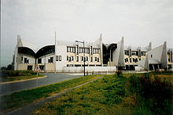
Santiago CalatravaValls (Valencian pronunciation: [santiˈaɣokalaˈtɾava ˈvaʎs], born 28 July 1951) | Is a Spanish architect, sculptor and structural engineer whose principal office is in Zürich, Switzerland. He has offices in Zürich, Paris and in New York City, where he now resides.  Сalatrava was born in Benimàmet, an old municipality now integrated as an urban part of Valencia, Spain, where he took an undergraduate architecture degree at the Polytechnic University of Valencia.^{[1]} There he completed independent projects with fellow students, publishing two books on the vernacular architecture of Valencia and Ibiza. In 1975 he enrolled in the Swiss Federal Institute of Technology in Zürich, Switzerland for graduate work in civil engineering. In 1981, after completing his doctoral thesis, "On the Foldability of Space Frames", he started his architecture and engineering practice. | 